# **Chapter 4: Project Planning**

## **4.1 WBS (Work Breakdown Structure)**

A Work Breakdown structure (WBS) is used in the project to break it down into manageable smaller parts making project easy to understand and helps to complete in time.

The reason of using WBS in arrangement for all project are as follows:

1. It helps in organizing the scope of whole project.
2. It helps to assign the control of project, responsibilities, etc.
3. It helps in making deliverables more accurate.

To evaluate the Work Breakdown Structure (WBS)

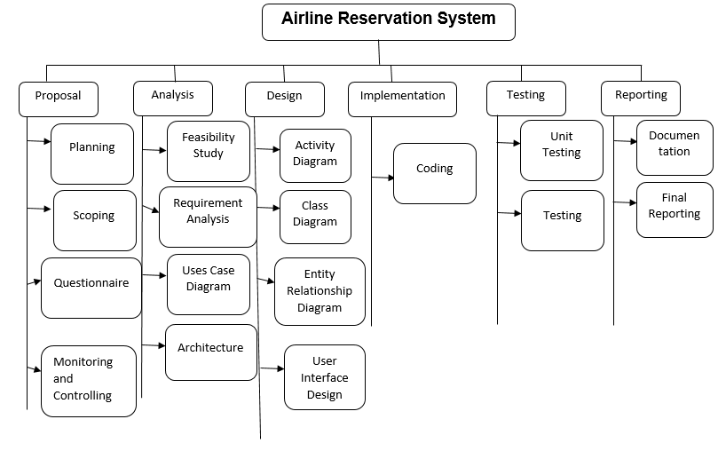

**Figure 4: Work Breakdown Structure**

## **4.2 Milestone**

The tools that are used in project management for measuring the progress of a project moving forward to its goal is known as milestone. It also helps you to be sure that you stay on track.

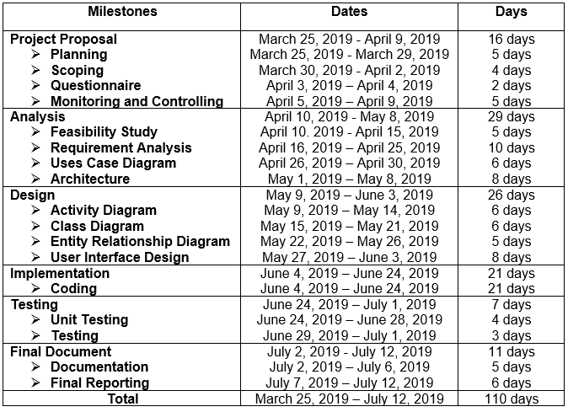

**Figure 5: Milestone**

The figure of my configuration system is created and shown above. I have made seven separate file named Proposal, Analysis, Design, Implementation, testing, Final Documentation and Backup. In the Proposal folder the report are created which includes proposal for this project. Then moving on to Analysis folder I have analyzed all the requirements needed for the development of the project after a good study and research. The Design folder holds the diagram likewise, activity diagram, class design, etc are all stored in design file. All the coding are saved in Implementation file. In testing file the output after unit testing applied in application is stored. In Final Reporting folder Final Documentation of this project is completed. At last in Backup folder the all other folder listed above is saved as per the change for managing the back up.

## **4.3 Gantt Chart**

Gantt chart is used in project management as it helps in representing activities such as events or tasks that is displayed against time. It will help in coordinating, planning and tracking the tasks in a project.

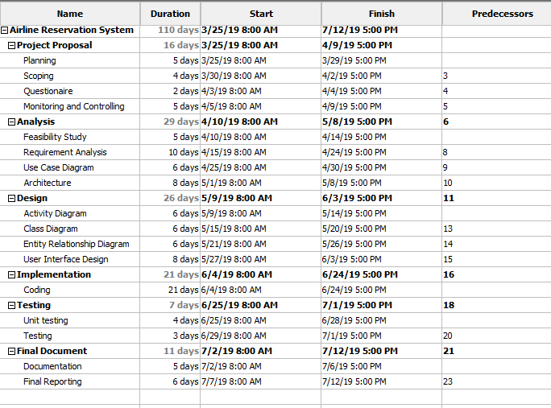

**Figure 6: Time Schedule**

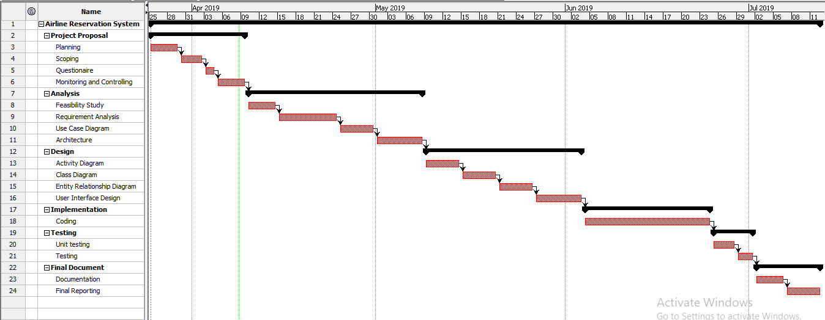

**Figure 7: Gantt chart**